Interger attacks

01- Ensure that unsigned integer operations do not wrap

1. Noncompliant Code Example (Addition)

#include <stdio.h>

void func(unsigned int ui_a, unsigned int ui_b) {
unsigned int usum = ui_a + ui_b; // Potential wrap
// Use usum as needed...
}

int main(void) {
unsigned int a = 3000000000; // Example value
unsigned int b = 2000000000; // Example value
func(a, b); // This will cause an unsigned wrap
return 0;
}

#include <stdio.h>
#include <limits.h>

void func(unsigned int ui_a, unsigned int ui_b) {
unsigned int usum;
if (UINT_MAX - ui_a < ui_b) {
// Handle error: unsigned integer wrap would occur
printf("Error: unsigned integer wrap would occur during addition\n");
} else {
usum = ui_a + ui_b;
// Use usum as needed...
printf("Sum: %u\n", usum);
}
}
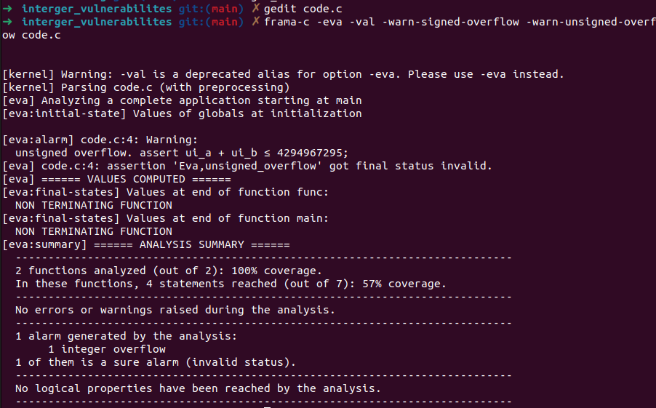

Compliant Solution (Precondition Test for Addition)

int main(void) {
unsigned int a = 3000000000; // Example value
unsigned int b = 2000000000; // Example value
func(a, b); // This will handle the wrap
return 0;
}

2 . Noncompliant Code Example (Subtraction)

#include <stdio.h>

void func(unsigned int ui_a, unsigned int ui_b) {
unsigned int udiff = ui_a - ui_b; // Potential wrap
// Use udiff as needed...
}

int main(void) {
unsigned int a = 1000; // Example value
unsigned int b = 2000; // Example value, causing potential wrap
func(a, b); // This will cause an unsigned wrap
return 0;
}

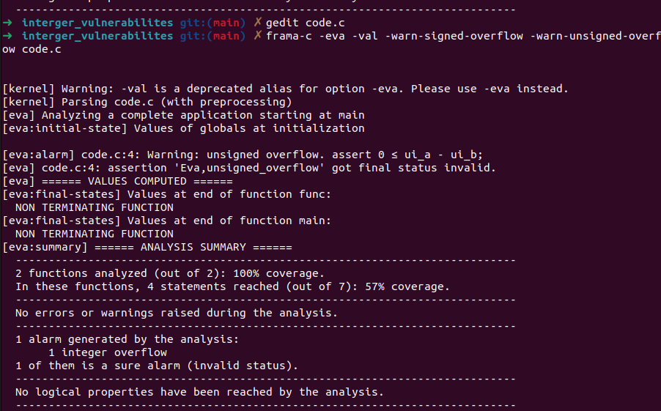
-

Compliant Solution (Precondition Test for Subtraction)

#include <stdio.h>

void func(unsigned int ui_a, unsigned int ui_b) {
unsigned int udiff;
if (ui_a < ui_b) {
// Handle error: unsigned integer wrap would occur
printf("Error: unsigned integer wrap would occur during subtraction\n");
} else {
udiff = ui_a - ui_b;
// Use udiff as needed...
printf("Difference: %u\n", udiff);
}
}

int main(void) {
unsigned int a = 1000; // Example value
unsigned int b = 2000; // Example value, causing potential wrap
func(a, b); // This will handle the wrap
return 0;
}

02 – Ensure that integer conversions do not result in lost or misinterpreted data

1. Noncompliant Code Example (Unsigned to Signed)

#include <stdio.h>
#include <limits.h>

void func(void) {
unsigned long int u_a = ULONG_MAX;
signed char sc;
sc = (signed char)u_a; // Cast eliminates warning
printf("Converted value: %d\n", sc); // Potentially incorrect value due to truncation
}

int main() {
func();
return 0;
}

